# Blinkit Analysis

This project provides a comprehensive analysis of Blinkit's sales data using SQL, focusing on key performance indicators (KPIs) and granular requirements. The analysis is structured to derive actionable insights for business optimization.

## Project Steps

**1. Database Creation:**

CREATE DATABASE Blinkitdb;

**2. Data Exploration:**

SELECT COUNT(*) FROM blinkit_data;

SELECT * FROM blinkit_data;

SHOW COLUMNS FROM Blinkit_data;

**3. Data Cleaning:**

ALTER TABLE blinkit_data

CHANGE COLUMN `ï»¿Item Fat Content` `Item Fat Content` VARCHAR(50);

SELECT DISTINCT(`Item Fat Content`)

FROM blinkit_data;

UPDATE blinkit_data

SET `Item Fat Content` = CASE

WHEN `Item Fat Content` = "LF" THEN "Low Fat"

WHEN `Item Fat Content` = "reg" THEN "regular"

ELSE `Item Fat Content`

END;

SELECT DISTINCT(`Item Fat Content`)

FROM blinkit_data;

**A. KPI’s**

**1. TOTAL SALES:**

SELECT CAST(SUM(`Total Sales`) / 1000000.0 AS DECIMAL(10,2)) AS Total_Sales_Million

FROM blinkit_data;

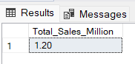

**2. AVERAGE SALES**

SELECT CAST(AVG(`Total_Sales`) AS INT) AS Avg_Sales

FROM blinkit_data;

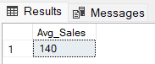

**3. NO OF ITEMS**

SELECT COUNT(*) AS No_of_Orders

FROM blinkit_data;

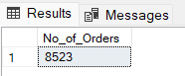

**4. AVG RATING**

SELECT CAST(AVG(`Rating`) AS DECIMAL(10,1)) AS Avg_Rating

FROM blinkit_data;

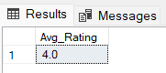

**B. Total Sales by Fat Content:**

SELECT `Item Fat Content`, CAST(SUM(`Total Sales`) AS DECIMAL(10,2)) AS Total_Sales

FROM blinkit_data

GROUP BY `Item Fat Content`;

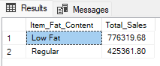

**C. Total Sales by Item Type**

SELECT `Item Type` , CAST(SUM(`Total Sales`) AS DECIMAL(10,2)) AS Total_Sales

FROM blinkit_data

GROUP BY `Item Type`

ORDER BY `Total Sales` DESC;

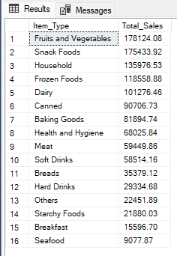

**D. Fat Content by Outlet for Total Sales**

SELECT `Outlet Location Type`,

       ISNULL([Low Fat], 0) AS Low_Fat,

       ISNULL([Regular], 0) AS Regular

FROM

(

    SELECT `Outlet Location Type`, `Item Fat Content`,

           CAST(SUM(`Total Sales`) AS DECIMAL(10,2)) AS Total_Sales

    FROM blinkit_data

    GROUP BY `Outlet Location Type`, `Item Fat Content`

) AS SourceTable

PIVOT

(

    SUM(`Total Sales`)

    FOR `Item Fat Content` IN ([Low Fat], [Regular])

) AS PivotTable

ORDER BY `Outlet Location Type`;

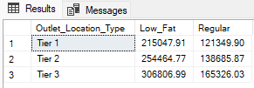

**Query Explanations**

This query aims to transform the blinkit_data table to display total sales (Total Sales) for each combination of Outlet Location Type and Item Fat Content. The result will show Outlet Location Type as rows and Item Fat Content categories ("Low Fat" and "Regular") as columns. If there are no sales for a particular combination, the query will display 0 instead of NULL.

**Detailed Explanation:**

1. **Subquery**
   * **Aggregation:**

*sql*

*CopyEdit*

*SELECT*

`Outlet Location Type`,*`Item Fat Content`,*

*CAST(SUM(`Total Sales`) AS DECIMAL(10,2)) AS Total_Sales*

*FROM*

*blinkit_data*

*GROUP BY*

`Outlet Location Type`,*`Item Fat Content`*

* **Purpose:** This subquery groups the data by Outlet_Location_Type and Item_Fat_Content, calculating the total sales for each combination.
* **CAST(SUM(Total_Sales) AS DECIMAL(10,2)):** Sums the Total_Sales for each group and casts the result to a decimal with two decimal places for precision.

1. **PIVOT Operation:**
   * **Pivoting:**

*sql*

*CopyEdit*

*PIVOT*

*(*

*SUM(Total_Sales)*

*FOR Item_Fat_Content IN ([Low Fat], [Regular])*

*) AS PivotTable*

* **Purpose:** Transforms the rows of Item_Fat_Content into columns ([Low Fat] and [Regular]).
* **SUM(Total_Sales):** Aggregates the Total_Sales for each Item_Fat_Content category within each Outlet_Location_Type.

1. **Main Query:**
   * **Selecting and Handling NULLs:**

*sql*

*CopyEdit*

*SELECT*

*Outlet_Location_Type,*

*ISNULL([Low Fat], 0) AS Low_Fat,*

*ISNULL([Regular], 0) AS Regular*

*FROM*

*PivotTable*

*ORDER BY*

*Outlet_Location_Type;*

* **ISNULL([Low Fat], 0) AS Low_Fat:** Replaces any NULL values in the [Low Fat] column with 0 and renames the column to Low_Fat.
* **ISNULL([Regular], 0) AS Regular:** Similarly, replaces NULL values in the [Regular] column with 0.
* **ORDER BY Outlet_Location_Type:** Sorts the final result set by Outlet_Location_Type.

**Why Use ISNULL?**

When performing a PIVOT operation, if a particular combination of Outlet_Location_Type and Item_Fat_Content doesn't exist in the data, the resulting cell will contain a NULL value. Using ISNULL(column)

**E. Total Sales by Outlet Establishment**

SELECT `Outlet Establishment Year`, CAST(SUM(`Total Sales`) AS DECIMAL(10,2)) AS Total_Sales

FROM blinkit_data

GROUP BY `Outlet Establishment Year`

ORDER BY `Outlet Establishment Year`

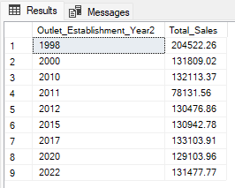

**F. Percentage of Sales by Outlet Size**

SELECT `Outlet Size`,

CAST(SUM(`Total Sales`) AS DECIMAL(10, 2)) AS Total_Sales,

CAST((SUM(`Total Sales`) * 100 / SUM(SUM(`Total Sales`)) OVER()) AS DECIMAL(10, 2)) AS Sales_Percentage

FROM blinkit_data

GROUP BY `Outlet Size`

ORDER BY Total_Sales DESC;

**Query Explanation:**

**Outlet_Size**: This column represents the size category of the outlet (e.g., Small, Medium, Large).

**CAST(SUM(Total_Sales) AS DECIMAL(10,2)) AS Total_Sales**:

* **SUM(Total_Sales)**: Calculates the total sales for each Outlet_Size.
* **CAST(... AS DECIMAL(10,2))**: Formats the resulting sum to a decimal number with two decimal places for precision.

**CAST((SUM(Total_Sales) * 100.0 / SUM(SUM(Total_Sales)) OVER()) AS DECIMAL(10,2)) AS Sales_Percentage**:

* **SUM(Total_Sales) * 100.0**: Multiplies the total sales of the current Outlet_Size by 100 to prepare for percentage calculation.
* **SUM(SUM(Total_Sales)) OVER()**:
  + **SUM(Total_Sales)**: Within the GROUP BY context, this computes the total sales for each Outlet_Size.
  + **SUM(... ) OVER()**: The outer SUM combined with the OVER() clause calculates the grand total of all Total_Sales across all outlet sizes without collapsing the result set.
* **SUM(Total_Sales) * 100.0 / SUM(SUM(Total_Sales)) OVER()**: Divides the total sales of the current Outlet_Size by the grand total sales and multiplies by 100 to get the percentage contribution of each outlet size to the overall sales.
* **CAST(... AS DECIMAL(10,2))**: Formats the resulting percentage to two decimal places.

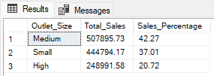

**G. Sales by Outlet Location**

SELECT `Outlet Location Type`, CAST(SUM(`Total Sales`) AS DECIMAL(10,2)) AS Total_Sales

FROM blinkit_data

GROUP BY `Outlet Location Type`

ORDER BY `Total Sales` DESC

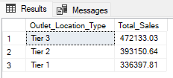

**H. All Metrics by Outlet Type:**

SELECT `Outlet Type`,

CAST(SUM(`Total Sales`) AS DECIMAL(10, 2)) AS Total_Sales,

CAST(AVG(`Total Sales`) AS DECIMAL(10, 2)) AS Avg_Sales,

COUNT(*) AS No_Of_Items,

CAST(AVG(`Rating`) AS DECIMAL(10, 2)) AS Avg_Rating,

CAST(AVG(`Item Visibility`) AS DECIMAL(10, 2)) AS Item_Visibility

FROM blinkit_data

GROUP BY `Outlet Type`

ORDER BY Total_Sales;

